Game Design Document

Fill up the following document

1. Write the title of your project.

Plant vs zombie

1. What is the goal of the game?

The goal of the game is to kill the zombies and collect points.

1. Write a brief story of your game.

# The story of the game– There is zombie world , where all the zombies live.There is a house in the zombie world where all the humans live , and as the favourite food of zombie is human brain , all the zombies want to attack the human house and eat out all the brains.To save the humans from the zombies the player plants a lot of plants which will attack those zombies and kill them and thus will save the humans from zombies.

1. Which are the playing characters of this game?

* Playing characters are the ones who respond to the user based on the input from the user.
* Cars, monkeys, dinos, wizards, etc., are the playing characters in the game.

|  |  |  |
| --- | --- | --- |
| Number | Character Name | What can this character do? |
| 1 | Peashooter | Shoot peas to kill the zombie |
| 2 | Walnut | When zombie touches it blast automatically to kill the zombie |
| 3 | Potato | It protects plant because zombie takes more time to eat it |
| 4 | Cherry bomb | Player can blast it on zombie to kill |
| 5 |  |  |
| 6 |  |  |
| 7 |  |  |
| 8 |  |  |

1. Which are the Non-Playing Characters of this game?

* Non-Playing characters are the ones that don't have an action or behavior when the user interacts with the game.
* Hurdles, stones, bananas, coins, etc., are non-playing characters in the game.

|  |  |  |
| --- | --- | --- |
| Number | Character Name | What can this character do? |
| 1 | Coins | The player can collect it to buy a plant |
| 2 | Flying zombie | This charcter can fly and eat the plants |
| 3 | Big zombie | This character is very big and idestroy the plants easily |
| 4 | zombie | It will come to eat the plants |
| 5 |  |  |
| 6 |  |  |
| 7 |  |  |
| 8 |  |  |

Draw your imagination of this game. What does this game look like?

* Draw the game either on your computer or on paper.
* Add images of the game scenes to show each of the playing and non-playing characters at least once.

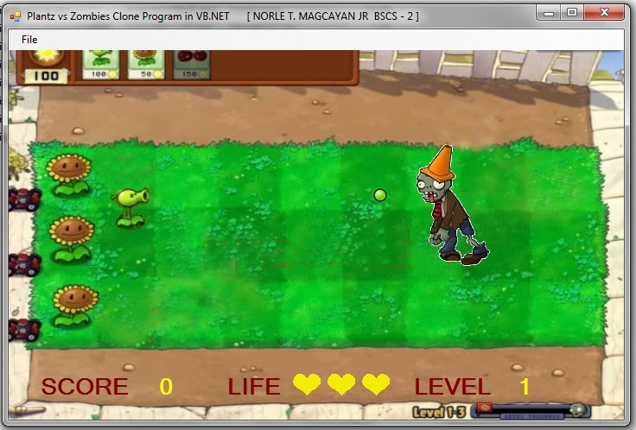

How do you plan to make your game engaging?

To make the game engaging , I will add big zombies , flying zombies , and different types of plants to kill the zombies.Every time a plant kills a zombie ,the player will get coins by which the player can plant a lot more plants.

